  - 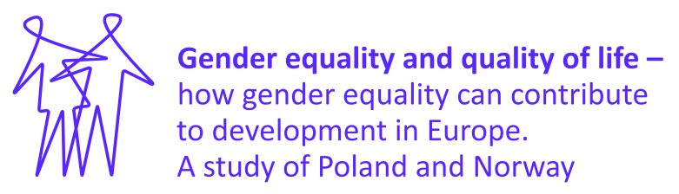

Summer School Confirmation
30 August – 4 September 2015
In order to confirm your participation in the Summer School please fill out and sign this form and return it by email as a scanned attachment to this address: geq@uj.edu.pl by 1 June 2015.
Please note that in case we do not receive your signed CONFIRMATION FORM by the deadline, we will have to withdraw you from the list of participants for the Summer School 2015.

Personal data:
Surname (last name): ………………………………………….
Given (first) name: ……………………………………………..
Date of Birth: ……………………………………………………..
VISA ISSUE
If you are NON – EU citizen, or if you are not eligible for visa free movement, you need to apply for Schengen Visa type C in order to participate in the Summer School. Please provide us with the following data which we will use to issue an invitation letter for you. Also please find more details about visa process below:
Place of Birth: …………………………………………………………..
Citizenship: …………………………………………………………..…..
Passport number: ……………………………………………………..
Address to which the visa letter should be sent: (we will also send a scanned version once we get the confirmation form)
……………………………………………………..
……………………………………………………..
……………………………………………………..
For a full list of visa-free countries please refer to: http://www.msz.gov.pl/en/travel_to_poland/entering_poland/visa_free/visa_free_countries
In order to start the visa application process, the applicant needs to go to the “e-Konsulat” website and choose the nearest Polish Consulate in his or her country: https://secure.e-konsulat.gov.pl/default.aspx and make an appointment and file the application in person. The visa application form can be downloaded from that website and the appointments at a given consulate can be scheduled.
General information about the documents that you need to submit you will find here: http://www.msz.gov.pl/en/travel_to_poland/visa/ but please refer to the proper Polish Consulate for further instructions for applying for visa.

Insurance policy/agreement
In order to be accepted you must agree to all of the following (please tick all appropriate boxes):
I confirm that I posses health and accident insurance that cover the whole of my expected stay in Poland.
I understand that I am obliged to have sufficient health and accident insurance to cover the whole of my expected stay in Poland and I understand that I must send a photocopy/or scan/ or fax of my insurance agreement before my arrival in Poland.
Jagiellonian University, and the officers, directors, employees, representatives and affiliates of this university (collectively the "Program Sponsors") do not assume any liability for acts, omissions or events which may occur as a result of, or in connection with, your participation in the program. Moreover, the Program Sponsors are not responsible for any delays, accidents, illness, disease, damage, or other costs which you may experience or incur in connection with your participation in the program.
By signing below you are agreeing to release, waive, acquit, discharge, indemnify and hold harmless each of the Program Sponsors from and against any and all claims, demands, causes of action and liabilities of whatever nature that have been asserted, could have been asserted or could be asserted in the future relating to or in any manner arising out of your participation in the program. In addition, you hereby expressly grant permission to the Program Sponsors to use photographs of you and/or your written or verbal statements during the program in future promotional material or for other purposes. By accepting the terms of this letter, you agree to release the Program Sponsors from any and all liability in connection with the use of such photographs, images, and statements.
The Program Sponsors reserve the right to terminate the participation of student whose behavior is determined to be detrimental in any way to the best interests of the program, as determined by the sponsors in their sole and absolute discretion. Termination due to an emergency or behavioral problem will be effective immediately.
Payment
I will pay the summer school fee by 14 June 2015.
I will cover my own travel costs and the cost of living in Kraków during the programme, excluding accommodation which is covered by the Jagiellonian University. The Program Sponsors will also cover summer school materials and participation in seminars.
Participation
I will participate in the entire programme (all seminars offered during Summer School).
Data Protection
I hereby give my consent for processing personal details for the purpose of the project: "Gender equality and quality of life - how gender equality can contribute to development in Europe. A study of Poland and Norway" (GEQ).
Final statement
Hereby I confirm I understand and accept all conditions and requirements of this registration form.
All information supplied by me on this application is, to the best of my knowledge, true and complete. I understand that misrepresentation is sufficient reason for denial of admission.
Date: …………………………
Signature: …………………………

